Order Of Service

Singing: Psalm 22—CW page 71

Reading: Psalm 32

Opening Hymn: TLH 239

Reading: II Corinthians 4:1-18

Request Hymn: CW Supplement 702

Reading: Mark 5:14-20

Sermon Hymn: TLH 237

Sermon Text: Luke 15:11-24

The Lost Son

Prayer

The Apostles’ Creed, TLH page 12

Holy Communion

The Lord's Prayer

The Blessing

Closing Hymn: TLH 248

************

Bible Study: Lambs: Irish Setter
Sheep: TBA
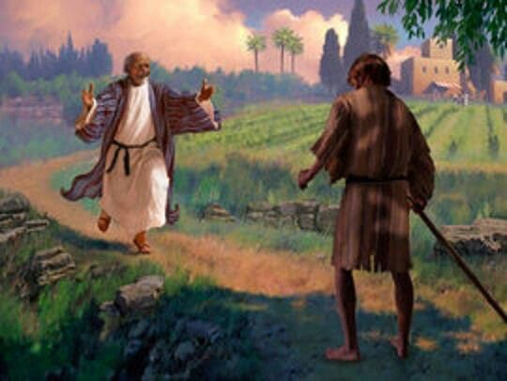

Welcome Home

Water
Of
Life

24 July 2022

W A T E R O F L I F E

Independent Christian Church—Conservative Lutheran Doctrine

Worship Service: 9:30 a.m.

Larry Cooper, Pastor E-Mail address:
111 N. Ridge Road lcooper@wateroflife.cc
Coon Valley, WI 54623 Web Site:
www.wateroflife.cc

* * * * * * * * * * * * * * * * * * * * * * * * * * *

Sermon Text: Luke 15:11-24

The Lost Son

* * * * * * * * * * * * * * * * * * * * * * * * * * *

11 And he said, A certain man had two sons:
12 And the younger of them said to his father, Father, give me the portion of goods that falleth to me. And he divided unto them his living.
13 And not many days after the younger son gathered all together, and took his journey into a far country, and there wasted his substance with riotous living.
14 And when he had spent all, there arose a mighty famine in that land; and he began to be in want.
15 And he went and joined himself to a citizen of that country; and he sent him into his fields to feed swine.
16 And he would fain have filled his belly with the husks that the swine did eat: and no man gave unto him.
17 And when he came to himself, he said, How many hired servants of my father's have bread enough and to spare, and I perish with hunger!
18 I will arise and go to my father, and will say unto him, Father, I have sinned against heaven, and before thee,
19 And am no more worthy to be called thy son: make me as one of thy hired servants.
20 And he arose, and came to his father. But when he was yet a great way off, his father saw him, and had compassion, and ran, and fell on his neck, and kissed him.
21 And the son said unto him, Father, I have sinned against heaven, and in thy sight, and am no more worthy to be called thy son.
22 But the father said to his servants, Bring forth the best robe, and put it on him; and put a ring on his hand, and shoes on his feet:
23 And bring hither the fatted calf, and kill it; and let us eat, and be merry:
24 For this my son was dead, and is alive again; he was lost, and is found. And they began to be merry.

